Press Release
Hellenic Centre for Marine Research
Institute of Marine Biology, Biotechnology and Aquaculture
“Educational Marine/Freshwater Areas (EAs) training seminar in Crete”
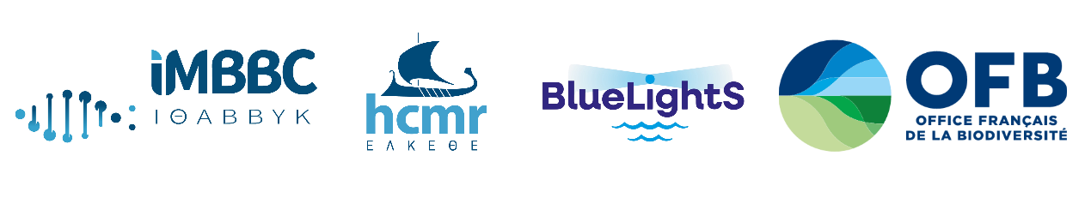
The three-day Educational Marine/Freshwater Areas (EAs) training seminar was successfully held in Heraklion, Crete, from 1 to 3 July, within the framework of the European-funded project BlueLightS, bringing together teachers, environmental educators, scientists, and representatives of environmental organizations with a shared goal: to co-develop the Educational Marine/Freshwater Areas methodology for implementation in Greece.
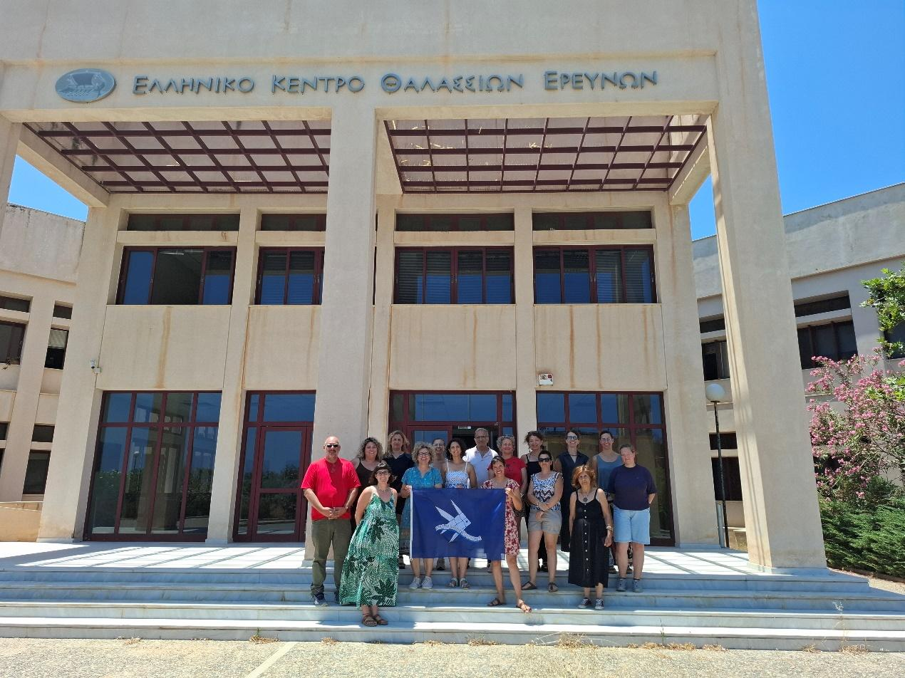
The training was conducted by the BlueLightS partner French Biodiversity Office (Office Français de la Biodiversité – OFB) in collaboration with the HCMR team partner, under the scientific coordination of Dr. Yolanda Koulouri, HCMR Research Director.
The first day focused on introducing the EAs methodology, while participants exchanged experiences and identified both the challenges and opportunities for its implementation in Greece. Through outdoor activities, they became familiar with environmental observation and mapping tools that can be integrated into educational practice.
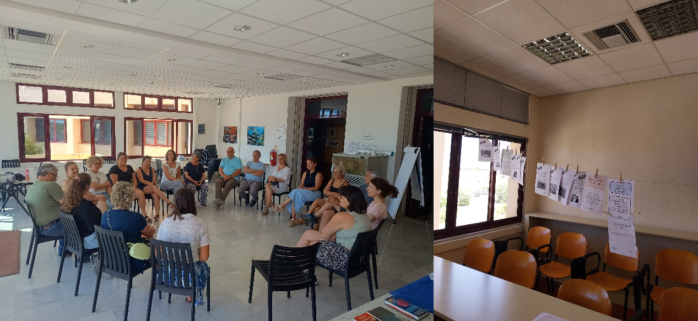
The second day was dedicated to simulating the implementation of an Educational Marine/Freshwater Area. Participants designed and presented field-based educational activities, took part in a simulated Council, where students collaboratively can make decisions about their EA, and developed educational resources corresponding to each stage of the EA methodology.
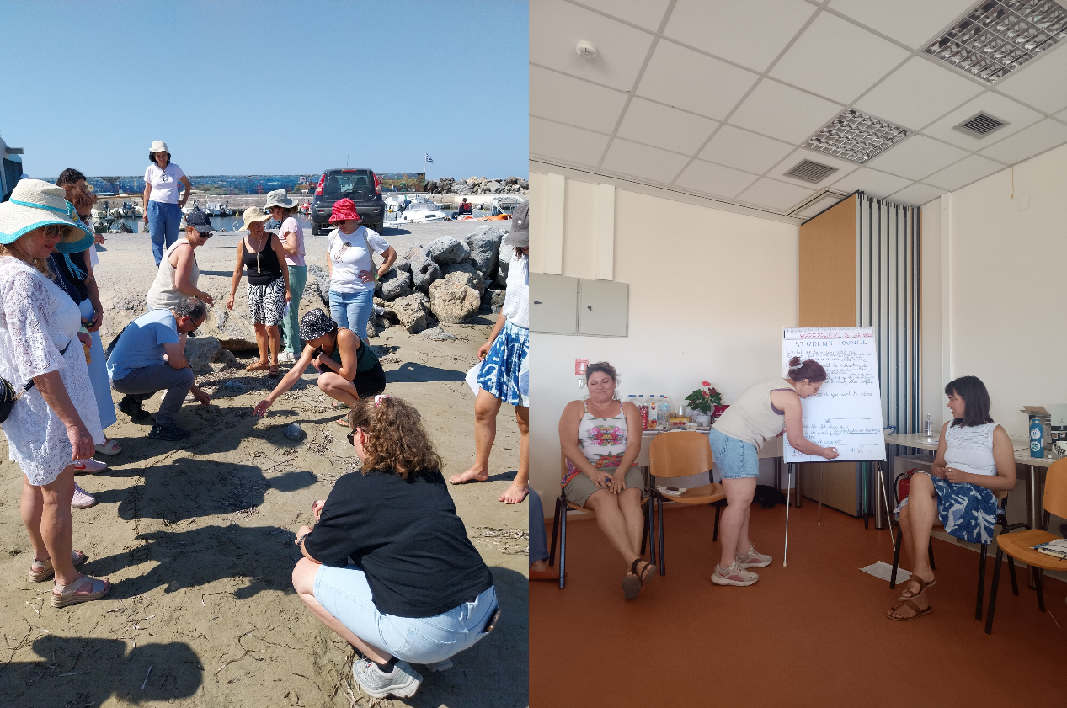
On the third day, participants worked together to co-design a Greek implementation framework for the EA methodology. Through group discussions, they identified the necessary adaptations, developed action plans, and formulated proposals for the pilot implementation of Educational Marine/Freshwater Areas in Greece, considering the needs of school communities and the importance of collaboration with local authorities, universities, research institutes and other environmental organizations.
The training highlighted the value of participatory marine/aquatic education and the importance of collaboration among schools, the scientific community, and local stakeholders in protecting the marine environment. It also established a strong network of teachers and educators as well as scientists and researchers, laying the foundations for the pilot development of the first Educational Marine/Freshwater Areas in Greece while identifying the key barriers to implementing such initiatives within the Greek formal educational system.
This initiative represents an important step towards strengthening ocean literacy and raising young people's awareness for aquatic conservation. By promoting their active participation in safeguarding biodiversity through innovative educational approaches that connect learning with local communities and the marine/aquatic environment, it also contributes to embedding blue education within Greek schools.
